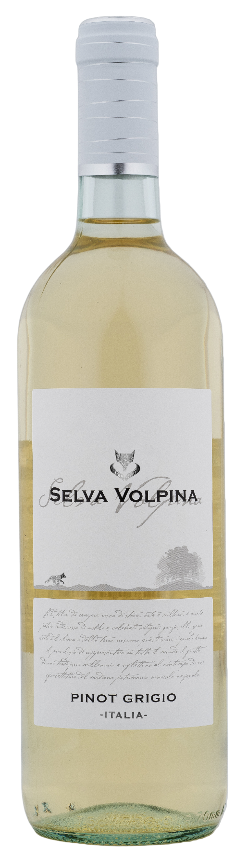
PINOT GRIGIO UMBRIA – SELVA VOLPINA

Grape: Pinot Grigio 100%
Alc. Vol.%: 12
Vintage: 2025
Residual sugar g/l: 4,9
Total acidity g/l: 5,6
Production zone: Vineyards in the region of Umbria (Provinces of Perugia and Terni)
Capacity: 750ml, 1500ml

CHARACTERISTICS

Vinification: Soft pressing and cold fermentation at a controlled temperature of 18°C
Yield per ha: 16000kg
Colour: Straw yellow with greenish reflections
Bouquet: Elegant, fruity and flowery
Flavour: Fresh, smooth and harmonious

SERVING SUGGESTIONS

Best enjoyed with fish dishes, seafood and light starters.
Serving temperature 8-10 °C
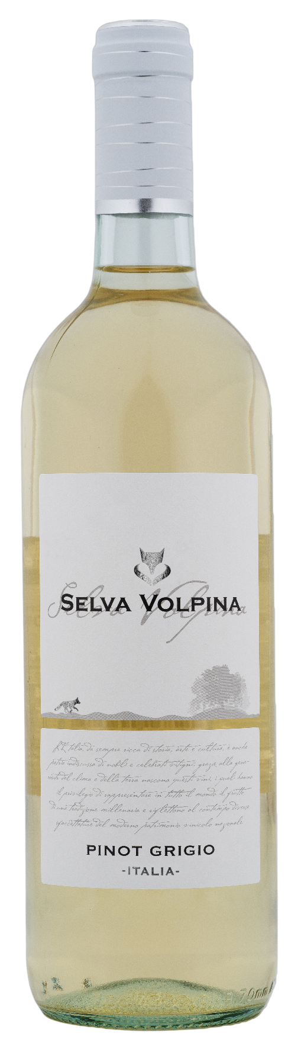
TECHNICAL INFORMATION / PALLETIZING

Size 750ml:
Article Nr. V10006A
GTIN-13 bottle 8017868002956
GTIN-13 carton 8017868002970
Closure Cork/Screwcap
Bottles / carton 6 bottles
Pallet size 80x120cm
Cartons/layer 25
Cartons/pallet 125
Kg/carton 7,2
Kg/pallet 925

Size 1500ml:
Article Nr. V10007B
GTIN-13 bottle 8017868002963
GTIN-13 carton 8017868002987
Closure Screwcap
Bottles / carton 6 bottles
Pallet size 80x120cm
Cartons/layer 14
Cartons/pallet 56
Kg/carton 13,4
Kg/pallet 790

Contains sulphites
GMO Free
Revisione 01. 14.05.2026

